How to reinstalling the Security and Compliance Dashboard:
Remove all the Security and Compliance Dashboard components circled in RED below:
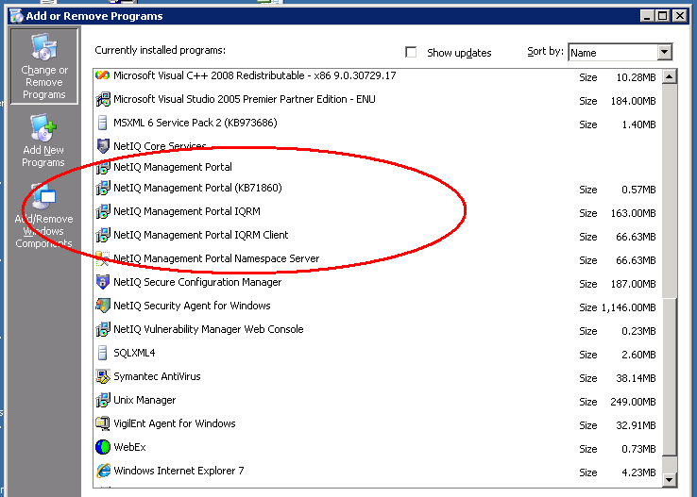

Verify the uninstaller removes the following sites listed below, if not manually remove them.
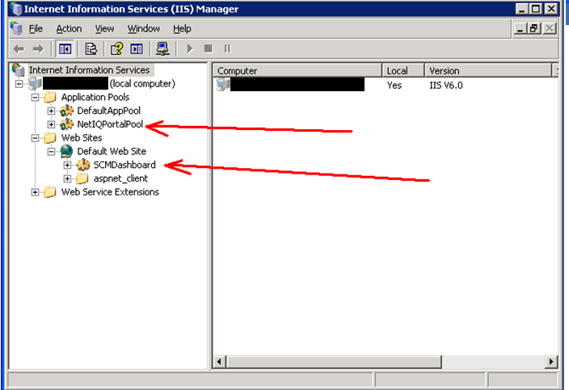

In Management Studio manually delete the listed databases below. This are Security and Compliance Dashboard databases.
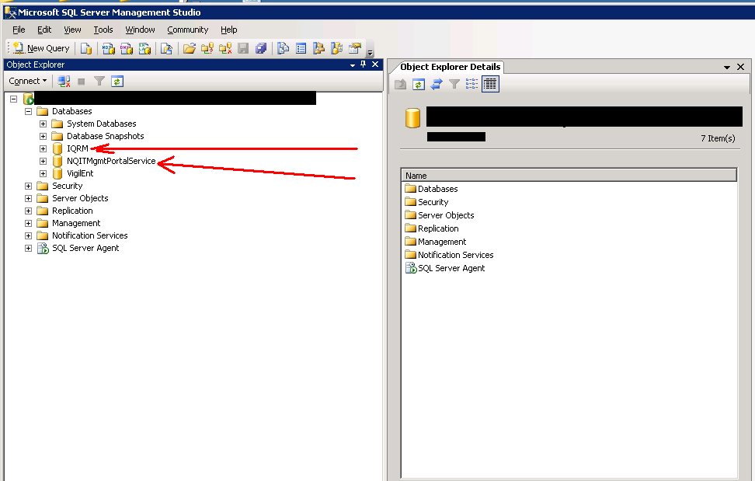

Verify the registry keys below are removed as well, if not manually remove.
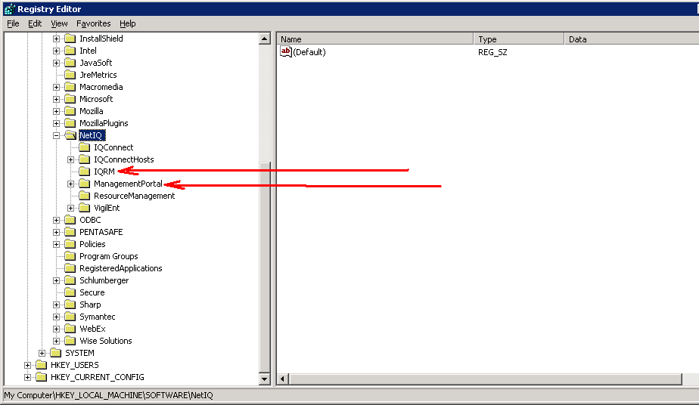

The installer should remove the following window directory below; however, if the ManagementPortal directory is here you need to manually delete the directory.
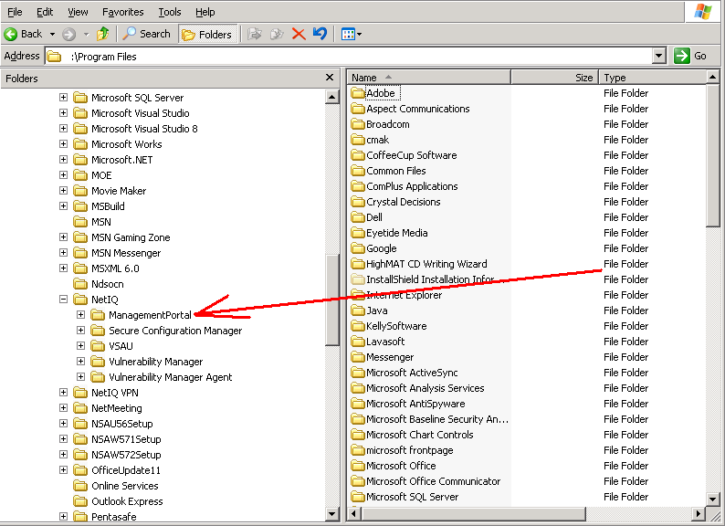

Once all the following Security and Compliance Dashboard Components have been removed, you may proceed with reinstalling the Security and Compliance Dashboard Components. Once the Security and Compliance Dashboard Install is complete, verify you have no install errors in the IQDABS_ManagementServiceDefinition.mof.txt in the screen shot below. Install directory may differ depending which hard drive you install on.
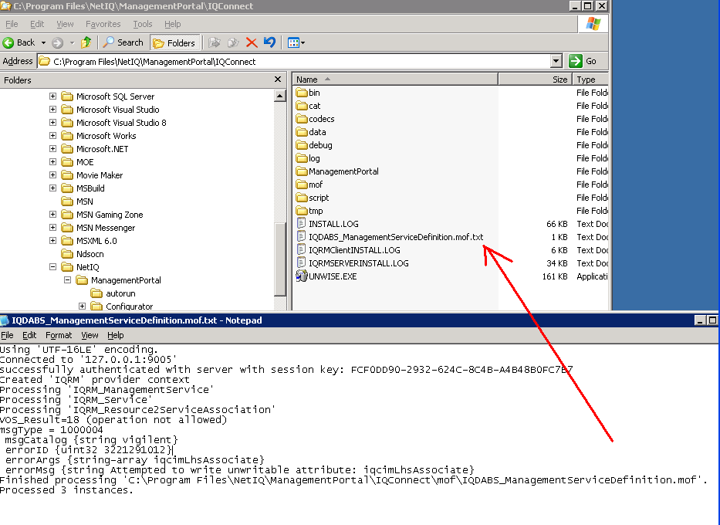

Next step is to verify the Security and Compliance Dashboard credentials the client has provided using the NetIQ Management Portal Configuration Utility for Resource Manager, Resource Manager Database, and Management Portal Database. Screen shots below:
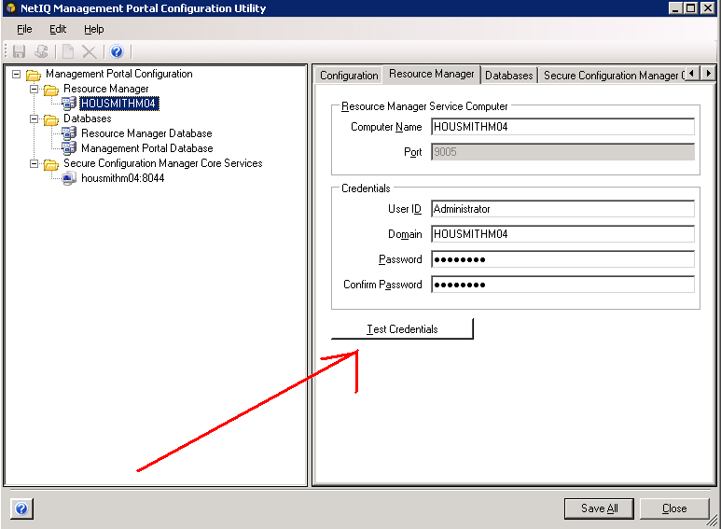
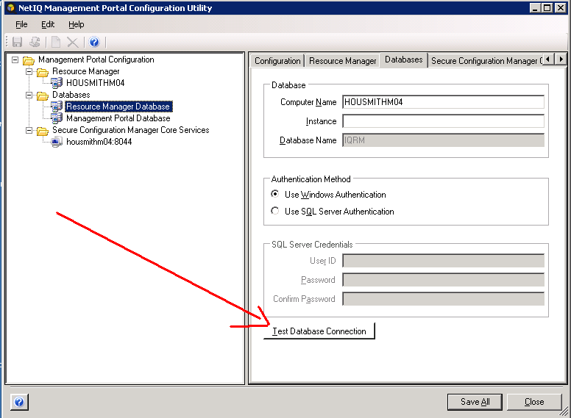
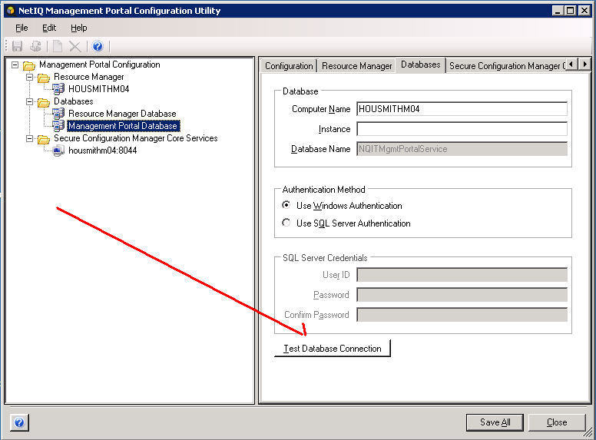
If all credentials test successfully you can proceed with trying to launch the Security and Compliance Dashboard in Internet Explorer.

